

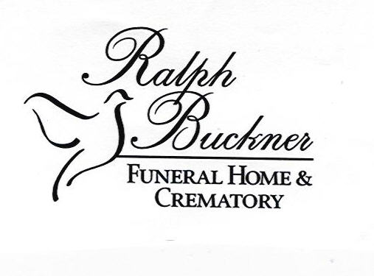

**65 Roses 5K Road Race Registration Form**



**Date :** March 28, 2015 **Time**: 8:30AM

**Registration**: You are encouraged to register prior to the day of the race with the form below or at [www.active.com](http://www.active.com/) (event_id=2136995**).**The entry form is below. Race-day registration and packet pick-up begins at 7:00AM the day of the race.

**Course**: The 5K (3.1 mile) course will begin and end at the Paul Conn Student Union on the campus of Lee University. It will wind through the Cleveland Historic District and Main Street Cleveland. This is a certified 5K course (TN 06041 DJR) – thank you David Presley.

**Cost**: The cost of the race is $30 before March 25, and $35 on race-day. Please make checks payable to the Cystic Fibrosis Foundation. (Cost of the fun run is $12 and $15.)

**Goodies**: The first 750 entrants will receive a dri-wicking running beanie; t-shirts will be at the finish. Awards are given (M/F) for Overall, Masters, Grand Masters, Senior Grand Masters, as well as 1st 2nd and 3rd place for runners in each of the following divisions: 10 & under, 11-14, 15-18, 19-24, 25-29, 30-34, 35-39, 40-44, 45-49, 50-54, 55-59, 60-64, 65+. The awards ceremony will begin at 9:30AM.

**Other**: For complete information please visit [www.leeuniversity.edu/cf](http://www.leeuniversity.edu/cf) . Please send all other questions to Bill Estes, 423.614.8479, [bestes@leeuniversity.edu](mailto:bestes@leeuniversity.edu)

Please return the CF Great Strides Road Race form below to:

65 Roses Road Race, c/o Dr. Bill Estes EB227, Lee University, Cleveland, TN 37320-3450

-----------------------------------------------------------------------------------------------------------

**2015 Great Strides Road Race**

Name______________________________________ Gender__________ Age on race day_____

Address_______________________________________________________________________

City________________________ State_____ Zip Code_____________ T-Shirt Size__________

Check All That Apply: 5K Race ($30)____ 1 Mile Fun Run ($12)____ Donation to the CF Foundation $_____

RELEASE AND WAIVER OF LEGAL RIGHTS

In consideration for your acceptance of this entry, I the below signed, intending to be legally bound for myself, my heirs, my executors and administrators, waive and release any and all rights and claims for damages I may have against the Great Strides Road Race, Lee University, the city of Cleveland, Tennessee, or any other groups or individuals associated with the Great Strides Road Race for any and all injuries suffered by me in this event. I attest and verify that I am physically fit and have sufficiently trained for the completion of this event. If entrant is under 18 years of age, parent or guardian must sign entry.

__________________________________________ _____________ _____________________________

Signed Date Parent or Guardian (if <18)

     [](http://webpages.leeu.edu/cf/sponsors-for-great-strides-of-cleveland/ftfc2/)

    C:\Users\bestes\Desktop\panddc.png 

[caldwell-paving-logo-horizontal-(1)](http://webpages.leeu.edu/cf/sponsors-for-great-strides-of-cleveland/caldwell-paving-logo-horizontal-1/)      cf

**Center for Cosmetic Dentistry**