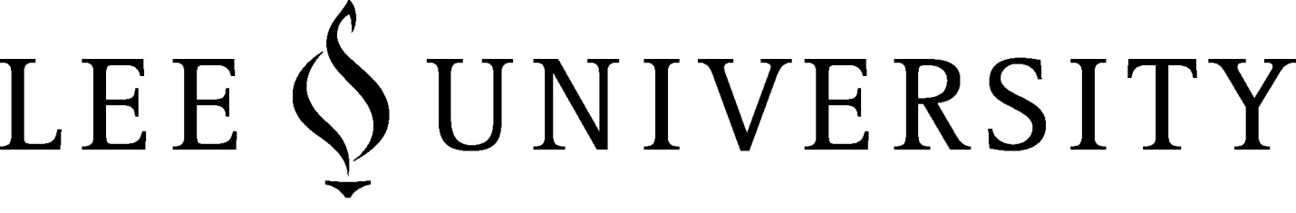
Department of Natural Sciences and Mathematics

GENERAL LABORATORY GUIDELINES VIOLATION POLICY
It is written in the Natural Science and Mathematics Department Policy Handbook that everyone that enters into a laboratory at Lee University should be dressed properly. These requirements, listed in the General Laboratory Guidelines, must be followed to ensure safety throughout the department. The Laboratory is a shared space, and these universal guidelines were established to ensure consistency in vital safety behaviors. These guidelines also ensure that we meet state and federal legal requirements established and enforced on behalf of the public.

If an individual does not come prepared for the laboratory experience; he/she will be sent home, will receive a ‘zero’ for the lab that he/she missed, and a Safety Violation Form will be filled out and sent to the Chemical Hygiene Officer (CHO). On a second offence, the individual will again be sent home, receive a ‘zero’ for the lab, and a second Safety Violation Form will be filled out and sent to the CHO. On a third offence, the individual will again be sent home, receive a ‘zero’ for the lab, and a third Safety Violation Form with be filled out and sent to the CHO.
WHEN a third Safety Violation Form is turned in to the CHO for the same individual for the same or multiple labs, faculty will be notified that the student will not be allowed to attend any labs and there will be a mandatory meeting with the Chair, Assistant Chair and the CHO. Following the meeting, the individual will have to complete an Understanding Lab Safety course that is provided by the CHO. The individual must pay for the training before starting, he/she must start training before reentering the laboratory at Lee University, and he/she will have two weeks to complete the training.
Upon a fourth violation, and fourth Safety Violation Form, the CHO will notify the Chair and the individual will fail that lab and the class with no withdrawal from the class.

